**Recursive function**

Recursive function is a function that calling itself. On other words it’s a function has function call statement inside its body.

**Syntax:**

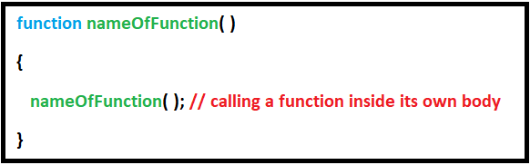

Identify:

a) Recursive behavior:

b) Base condition:

Then Code:

**Example:** on making a program used to find the factorial of a given number.

